Interface technical assessment
Candidate need to develop the below Data filter pages
- Develop the Data filter – to assess HTML, CSS/LESS, JS/JQuery skills
- Mobile design of the data filter - is to assess their responsive skills

- Data fiter Requirement description:
The page will have the list of bank account and the payment details of each bank the company holds an account.
The data should be stored in local JSON and should be fetched through AJAX call, so that the table data will be dynamic based on JSON data.
Create a HTML template for table and filter. The filter is used to sort, select specific bank and search on bank name. Use JavaScript sub sorting, no plugin should be used. 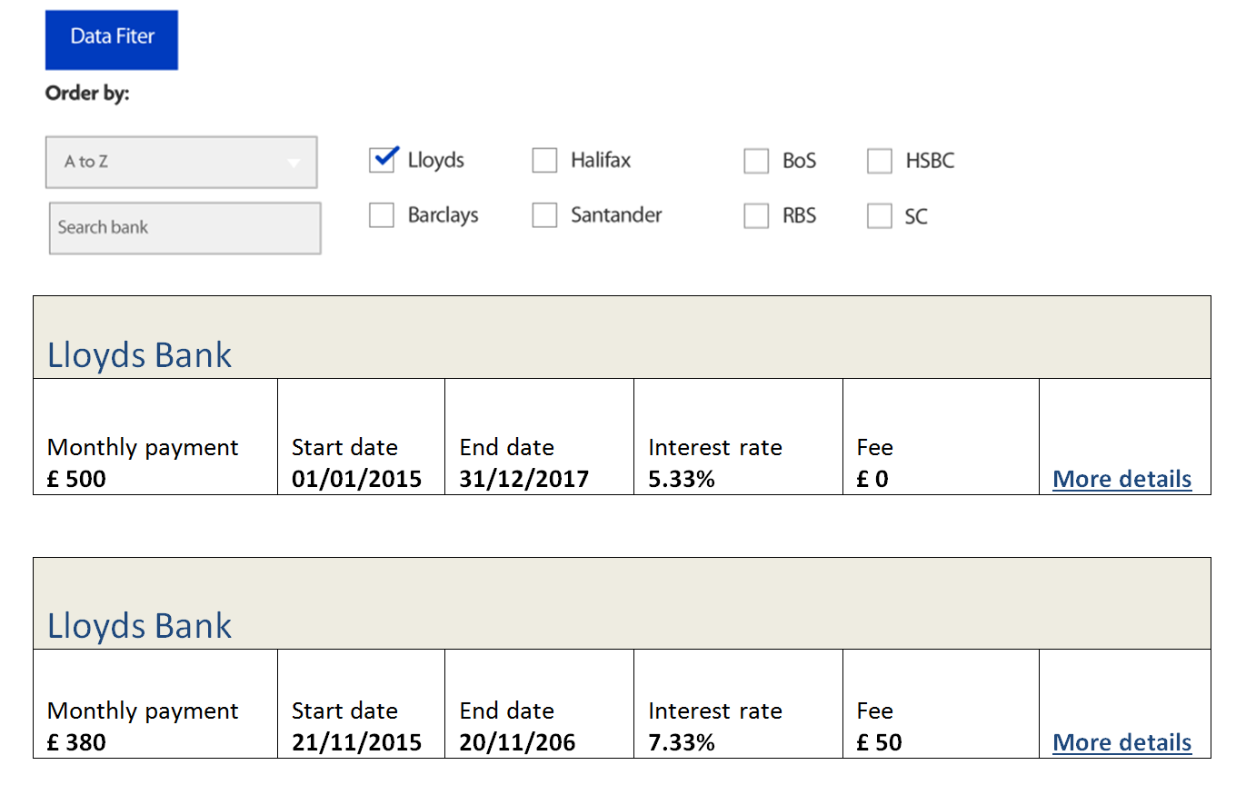

Use HTML, Less/CSS (preferably less), JS/JQuery to develop the layout and table design.

Sort: It should sort the list of banks in ascending/descending order, also by interest rate. List of options are A to Z, Z to A, Interest rate. Use JavaScript sub sort
Search: on type the character on text box should list out the banks if available, use JavaScript not plugin
Checkbox: List of banks account opened. On selecting one or more bank, the particular details should be displayed. By default all should be selected.
- Responsive design

Use media queries where the page should adapt to phone, tablet and desktop. The below design should be only for the mobile devices. For tablet view, use desktop design above.
